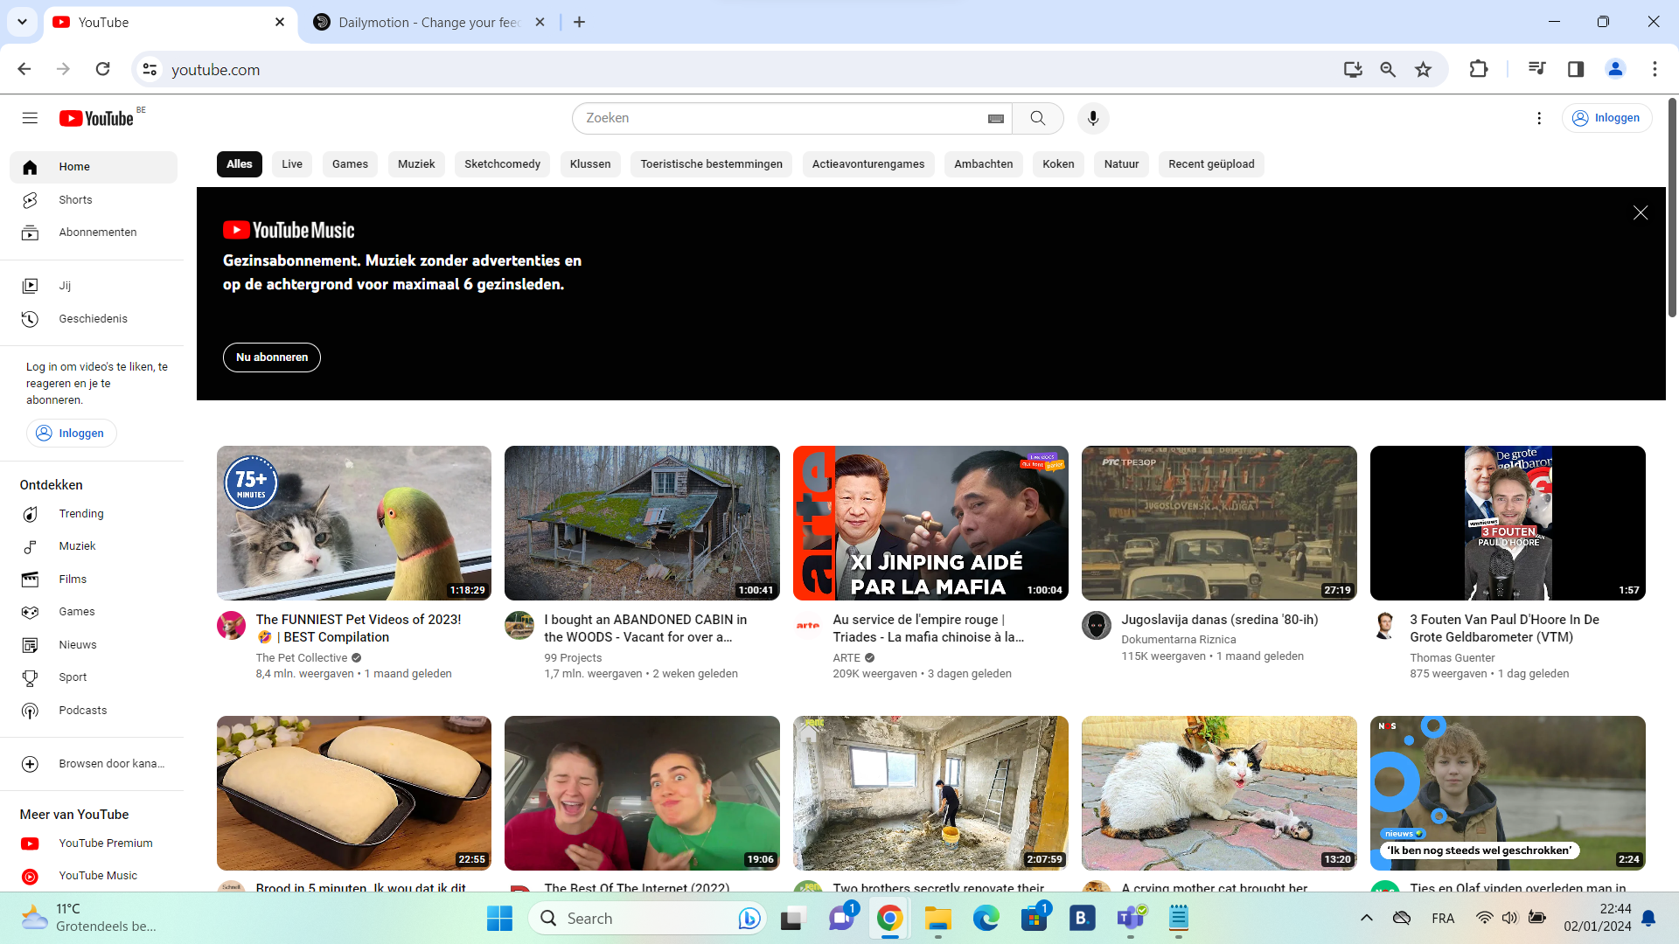
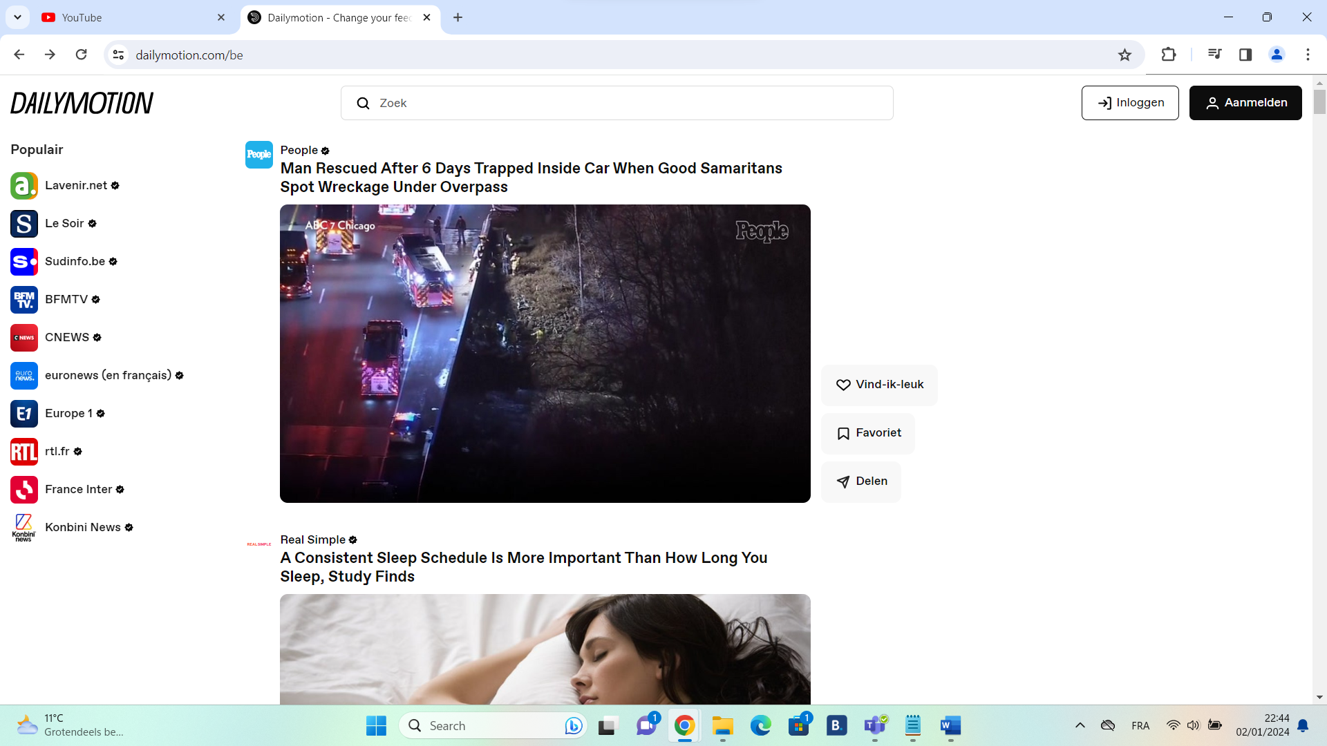

For this assignment I’ll be observing the two online video platforms Youtube and Dailymotion. We’ll be focusing on the design and features of each website to understand what attracts the consumer to each of these websites. This information would be indeed useful in case we want to make our own video sharing platform one day.
Important to note is that I’ve never used Dailymotion before, and the screenshots of Youtube are done while I’m logged off from my Youtube account, so it’s unlikely that my prior views have impacted the video displayed in homepage.
We’ll first observe the first screen, which is meant to invite the user to their website. As you can see, Youtube has more video that are more “trendy,” with there being video’s that have more than a million views and even the video’s that don’t have million views at least having a topic that would get a lot of people listening (politics, pet video’s). However, Dailymotion merely shows recent videos made by news outlets that upload videos with titles similar to that of an article. This might show that both sides have different goals in mind. Youtube wants to be more an entertainment platform while Dailymotion wants to be more of a news platform. That said, the priority of each homepage is to catch the attention of the user.
Youtube also advertises “Youtube Music” at the top of the page, which you can only get by buying the premium version of Youtube. Youtube going through lengths to convince people to buy Youtube Premium is not surprising considering some things Youtube has done such as preventing adblockers from working with Youtube (which would persuade the user to buy the premium version, because that version has no ads).
Even when that specific “Youtube Music” ad doesn’t appear in the home page. There will at least be a small pop-up at the bottom left advertising Youtube Premium.
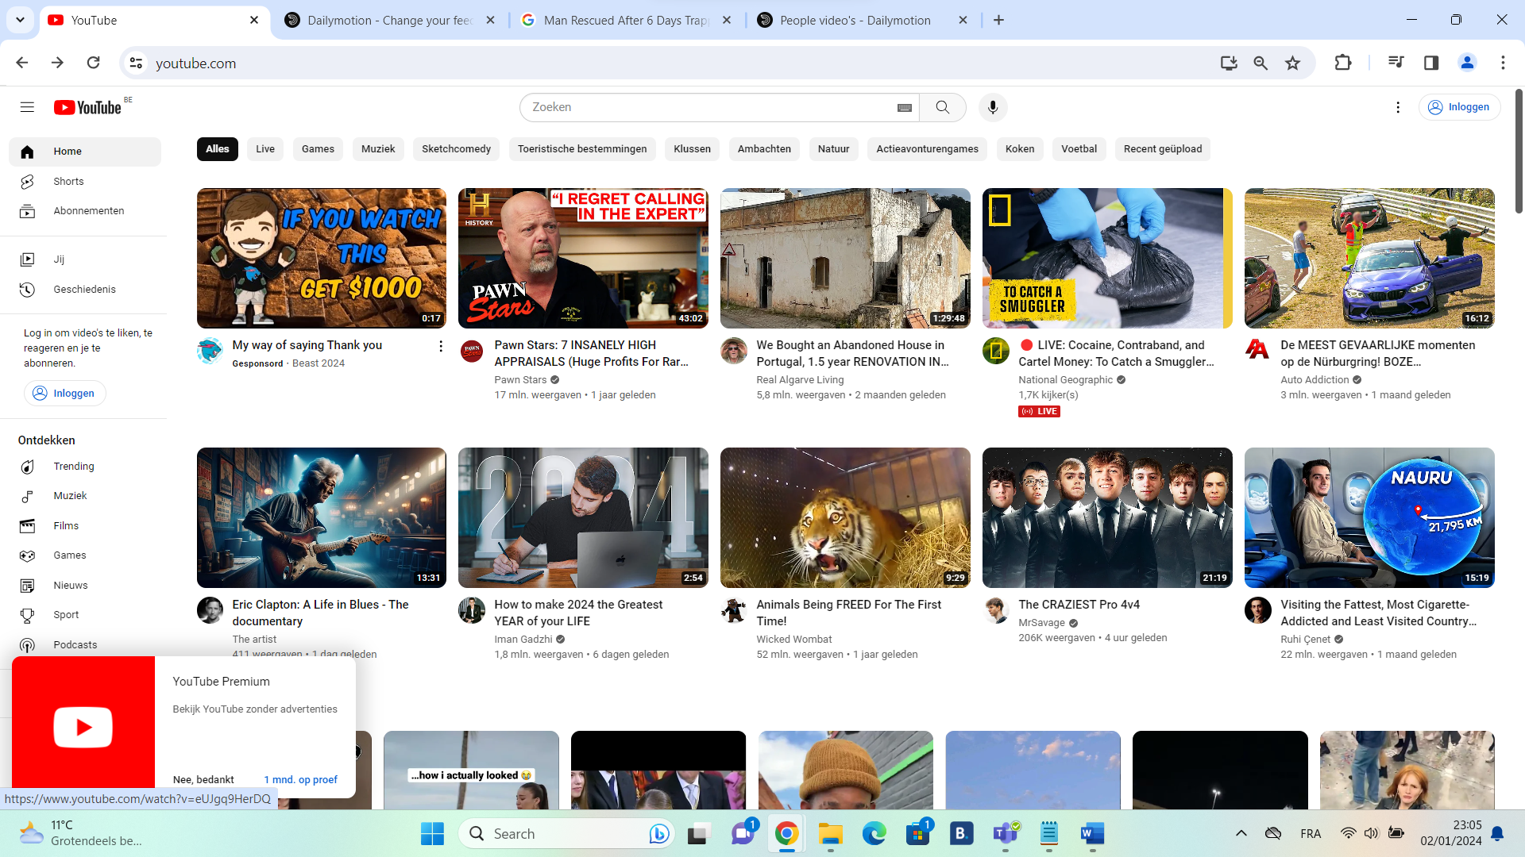
Youtube advertises its features more than Dailymotion, as it includes things such as links to the “subscriptions” page (“Abonnementen” in this Dutch version used in the photo), which would only be accessible as long as the user has an account. This implies that Youtube wants the user to make an account, which indeed would enhance the experience as it enables convenient features such as keeping track of a Youtuber you like through subscriptions, and an algorithm that would keep track of what kind of video’s you’d like. Meanwhile, Dailymotion only has a login and register button at the top right of their homepage to advertise their features. Instead of a counter at the left that would show these features like with Youtube, they only give links to the news outlets that they’re advetising and presumably associated with. This again displays their separate goals.
Both sites do have a priority to be as convenient and accesible as possible, and Dailymotion tries this in a way Youtube doesn’t. Dailymotion plays a video on the homepage when it’s on screen. They even give the viewer a quick “like,” “favorite,” and “share” button so the viewer can do these tasks rather quickly. Youtube doesn’t do this, presumably because its content consists of many content creators that appeal to different target audiences. Meanwhile Dailymotion just shows recent news and articles that would interest the viewer regardless of what channel it is from.
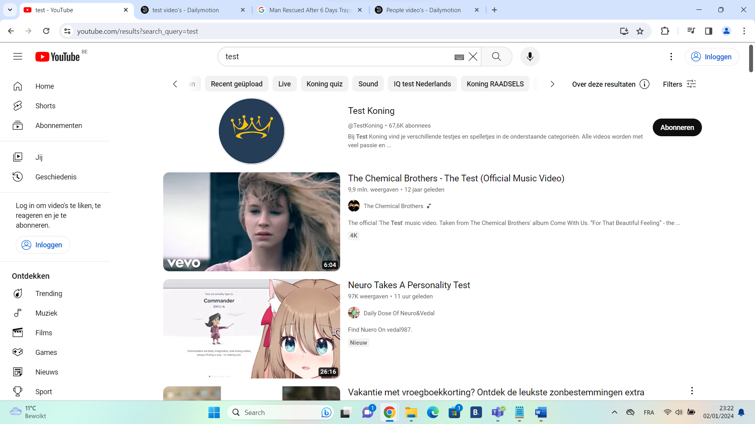
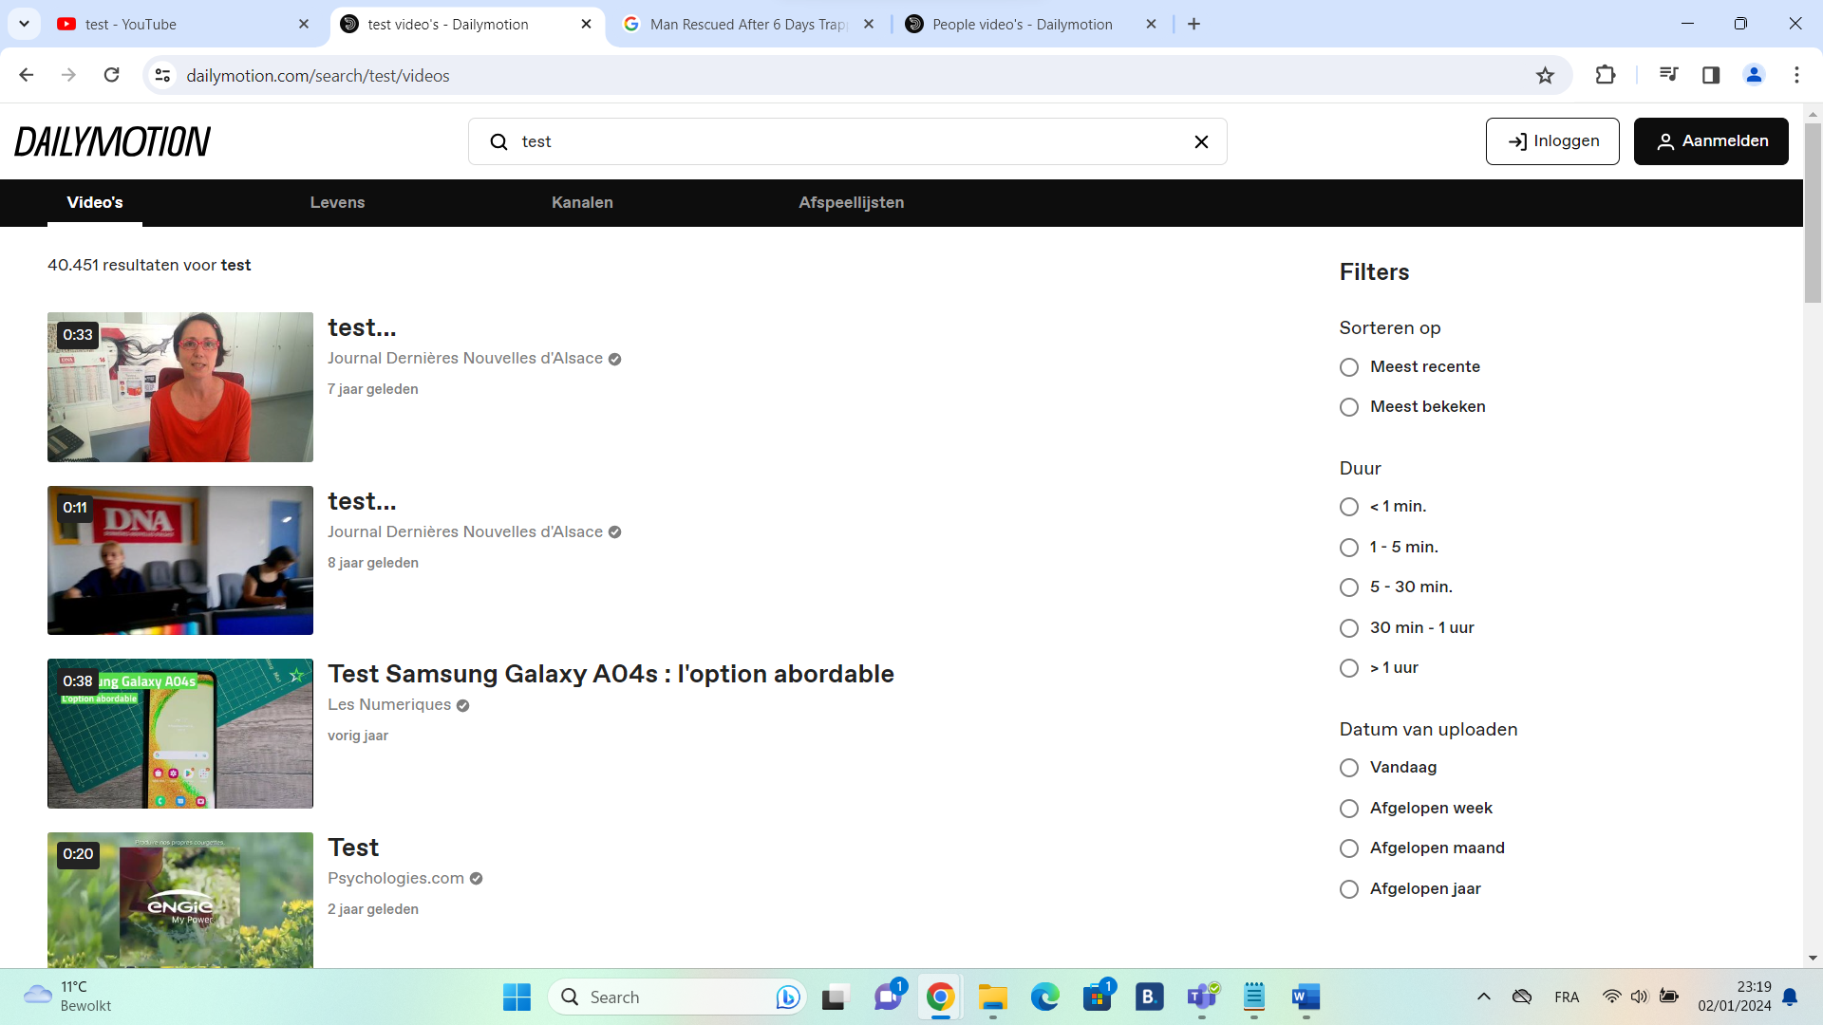
Both sites appear to have a difference in their design philosophy when it comes to the search page. Dailymotion shows the filter options immediately, whereas with Youtube you have to press on a button to see it. Youtube probably did this to not overwhelm the user (who could be a child or a teenager and thus prefer a more simpler design).

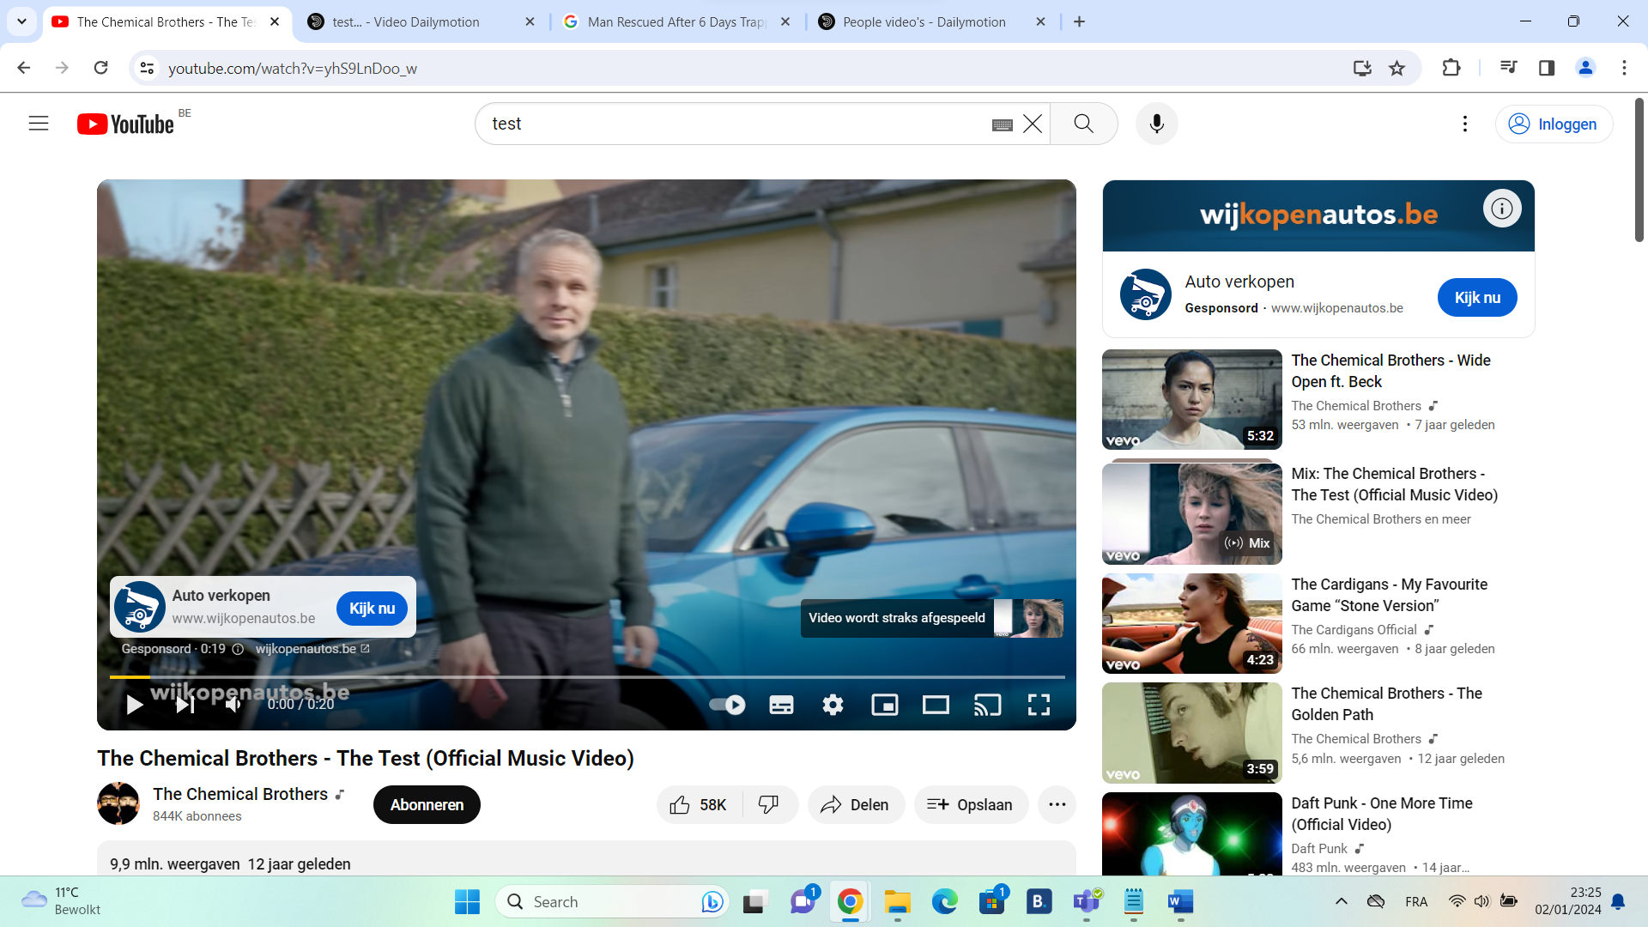
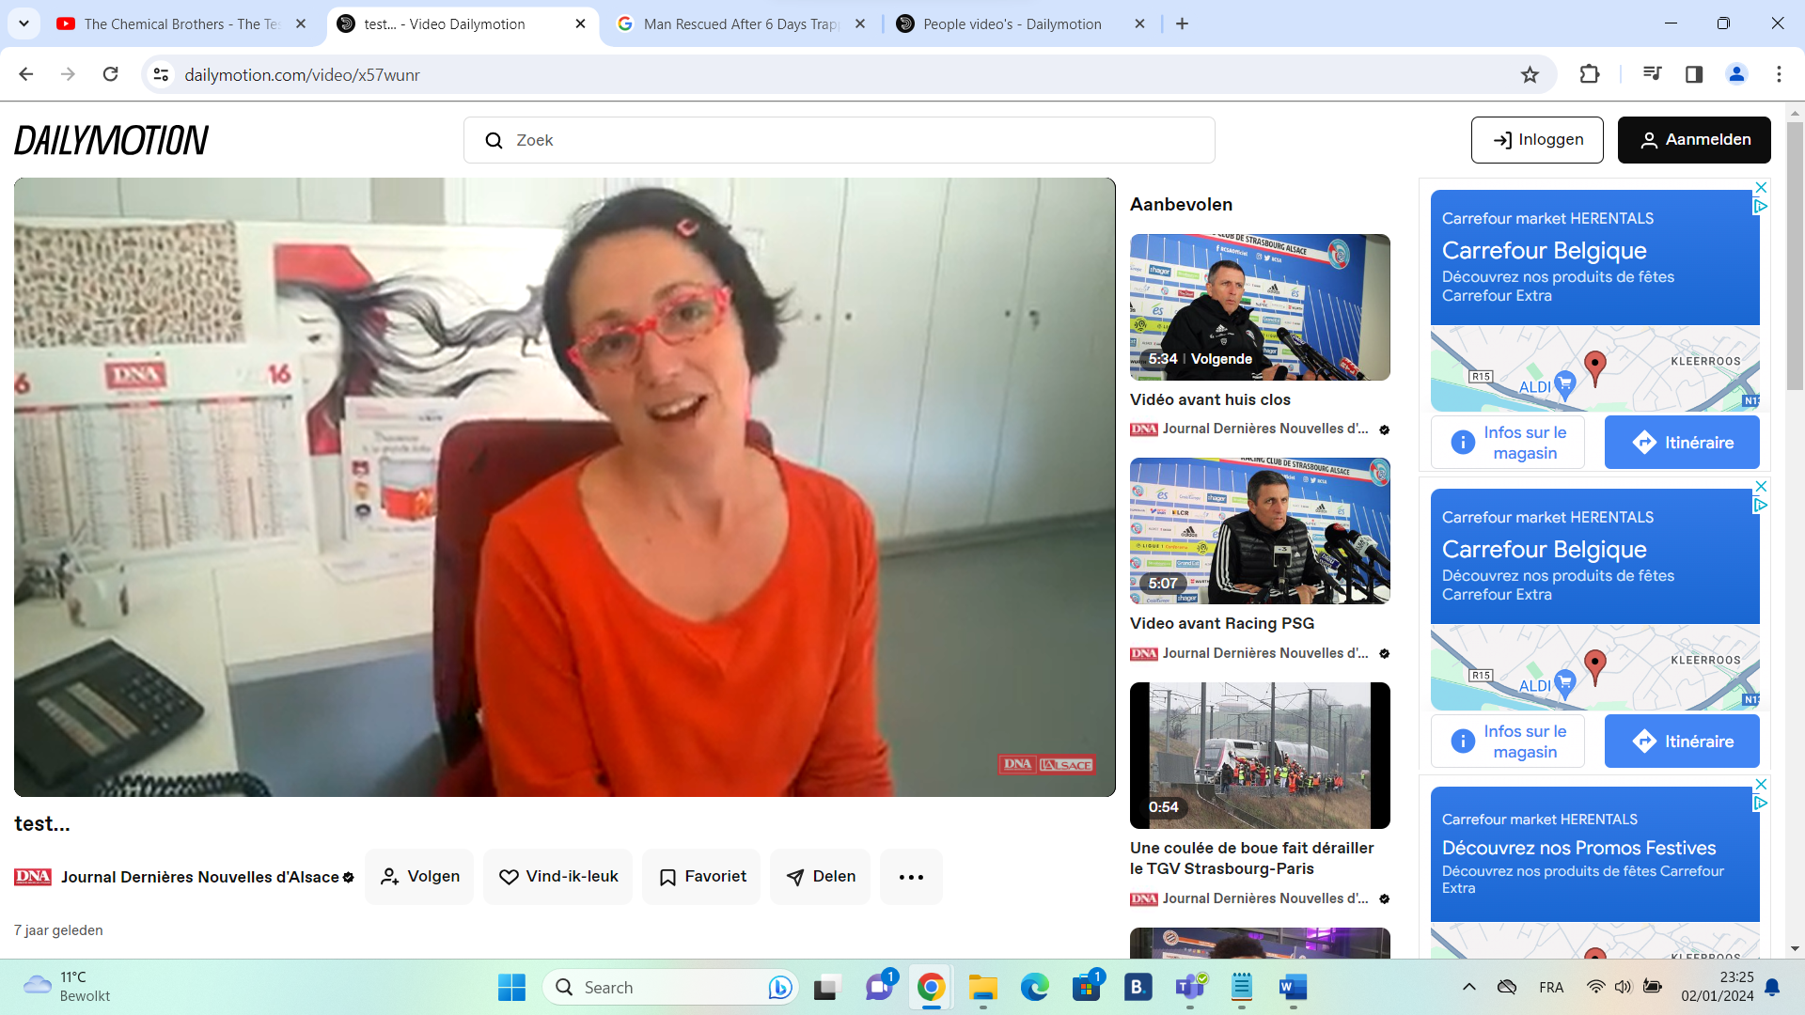
The two design philosophies when it comes to the page where you view videos however are pretty similar. However, they do display their advertisements in different ways. While both can play an advertisement in the video, Dailymotion also shows advertisements on the side in a small popup. Youtube noticeably doesn’t try to do this and shows a popup with a creative border that leads to the website of the thing that they’re advertising. This could be because Youtube is really popular and in order to maintain that popularity, they have to have a consistent layout and popups such as the one Dailymotion uses would only make the site look less profesionnal and less accessible to kids. This could be the same reason why Youtube removed the ability for users to customize their profiles, as such a feature would remove the consistency of the design.
Both sites show their features at bottom of the video. This time there is not much of a difference between the two.

